
Tripoli Motor Testing Division
223 NC Highway 54 West
Chapel Hill, NC 27514
(919) 357 5681 (c)
April 17, 2024

Gary Rosenfield
RCS Rocket Motor Components, Inc.
2113 West 850 North Street
Cedar City, UT 84721

Dear Mr. Rosenfield,

The Aerotech M2700W-PS reload kit was tested on March 30, 2024 and complies with NFPA 1125. The motor is certified for hobby rocketry use by the members of the Tripoli Rocketry Association and all approving organizations with reciprocal certifying agreements.

Motor Manufacturer RCS Rocket Motor Components, Inc.
Manufacturer’s Designation M2700W-PS [for the 75/10240 hardware]
Propellant White Lightning
TMT Nomenclature 10,322 N2717

Diameter 2.968” 75.39 mm
Overall Length 48.52” 1232.5 mm
Outside the MMT 1.60” 40.69 mm

Loaded Mass 19.97 lb 9058.2 g
Propellant Mass 11.629 lb* 5275 g*
Burnout Mass 7.58 lb 3438.2 g
* = data provided by manufacturer

Burn time 3.962, 3.635 sec [average = 3.799 sec]

Total Impulse 2399.4, 2241.3 lbf.s 10,637, 9969.7 N.s
[2320.4 lbf.s] [10,322 N.s]

Max Impulse 1248.5, 830.82 lbf 5553.5, 3695.7 N
[1039.7 lbf] [4624.6 N]

Average Impulse 605.31, 616.25 lbf 2692.6, 2741.2 N
[610.8 lbf] [2716.9 N]

Number of Motors Tested 2

Nominal Measured
Delay Time Data n.a. n.a.

Casing Temp. [NFPA 1125 7.4.1] Passed

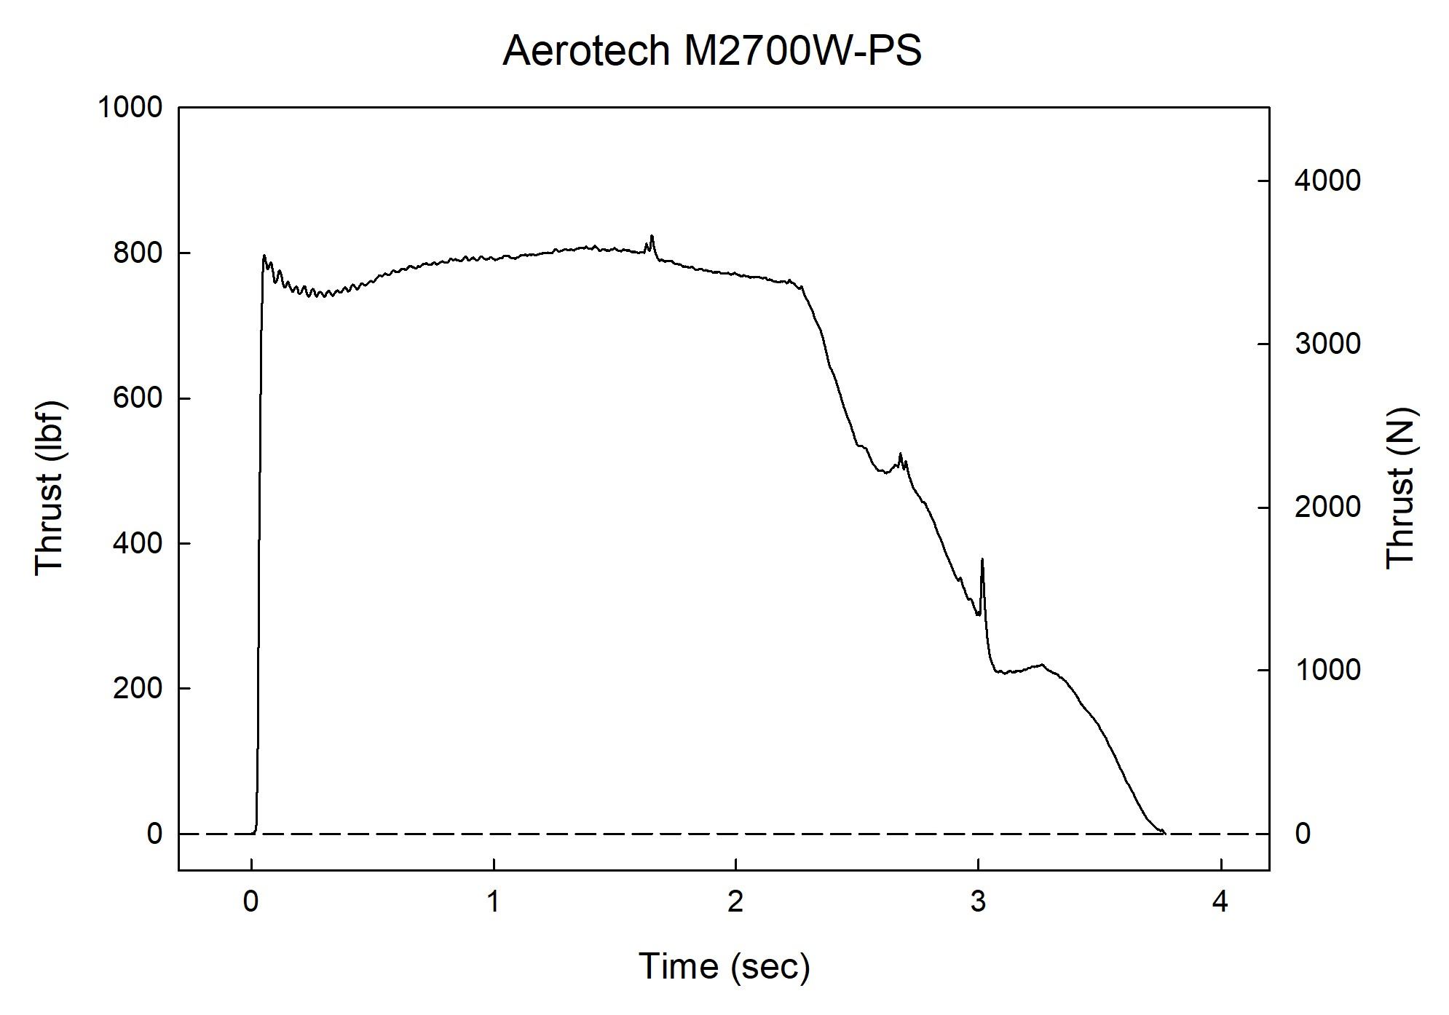
Sincerely,

Alan C. Whitmore

Chair, Tripoli Motor Testing

